Objective: Build a Flask application with a JSON API route and a frontend form that stores submitted data in MongoDB Atlas, with proper success and error handling.

Task 1: JSON API Route
- Create a Flask application with an /api route. When this route is accessed, it should return a JSON list. The data should be stored in a backend file, read from it, and sent as a response.
1. Project Structure
The project contains the Flask application file and a separate backend JSON data file. Keeping the data outside app.py satisfies the requirement that the API should read its response from a backend file.
flask_project/
├── app.py
└── data.json
2. Backend Data File: data.json
The data.json file stores a list of student/course records in JSON format. Each object has an id, name, and course.
[
{
"id": 1,
"name": "Poorvitha",
"course": "Python"
},
{
"id": 2,
"name": "John",
"course": "Flask"
},
{
"id": 3,
"name": "Sara",
"course": "MongoDB"
}
]
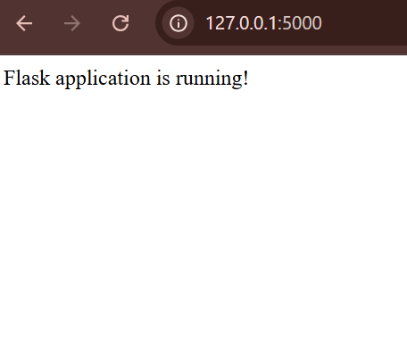Code Explanation
- from flask import Flask, jsonify: Flask creates the web application. jsonify converts Python data into a valid JSON HTTP response.
- import json: Imports Python's built-in JSON module so the application can read data.json.
- app = Flask(__name__): Creates the Flask application instance.
- @app.route('/'): Defines the home route. Opening the base address displays a message confirming that Flask is running.
- @app.route('/api'): Defines the JSON API endpoint. A browser request to /api runs the api() function.
- open('data.json', 'r'): Opens the backend data file in read mode.
- json.load(file): Reads and converts the JSON file content into a Python list containing dictionaries.
- jsonify(data), 200: Returns the data as JSON. HTTP status code 200 means the request was successful.
- FileNotFoundError: Returns status code 404 if data.json cannot be found.
- json.JSONDecodeError: Returns status code 500 if data.json contains invalid JSON syntax.
- app.run(debug=True): Starts the local development server with debugging enabled

Running and Testing the Application
- Open the VS Code terminal inside the flask_project folder.
- Install Flask using: pip install flask
- Run the application using: python app.py
- Open the local home page at http://127.0.0.1:5000
- Open the API endpoint at http://127.0.0.1:5000/api
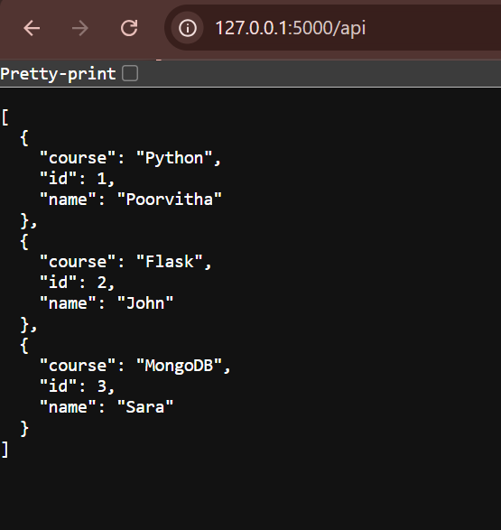

Task 2: Frontend Form with MongoDB Atlas
- Create a form on the frontend that, when submitted, inserts data into MongoDB Atlas.
- On success: the user should be redirected to another page displaying the message “Data submitted successfully”.
- On error: display the error on the same page without redirection.

Step 1: Installed required packages
I installed the required Python packages:
pip install pymongo
pip install python-dotenv
pip install certify
- pymongo is used to connect Python to MongoDB.
- python-dotenv is used to read MongoDB credentials from the .env file.
- certifi provides CA certificates for the secure MongoDB connection.

Step 2: Configured MongoDB Atlas
- I created a MongoDB Atlas cluster and created a database user.
- I also configured the IP Access List so that my system was allowed to connect to the MongoDB Atlas cluster.
- The database credentials were stored separately in a .env file instead of putting the password directly inside app.py.
MONGO_USERNAME=database_username
MONGO_PASSWORD=database_password
MONGO_HOST=cluster_address

Step 3: Connected Flask to MongoDB
In app.py, I loaded the environment variables and established a MongoDB connection using MongoClient.
The application uses:
Database: student_database
Collection: students
Step 4: Created the frontend form
I created:
templates/form.html
Step 5: Created the /submit route
I created a Flask route to process the submitted form:
@app.route('/submit', methods=['POST'])
The route gets the values entered by the user:
name = request.form.get('name', '').strip()
course = request.form.get('course', '').strip()
Step 6: Success Handling
When MongoDB successfully inserts the record, the application redirects the user:
return redirect(url_for('success'))
The /success route opens success.html.
Step 7: Error Handling
I implemented error handling using try and except.
try:
collection.insert_one(student_data)
return redirect(url_for('success'))
except Exception as error:
return render_template(
'form.html',
error=str(error)
)
Step 8: Testing
I tested both scenarios.

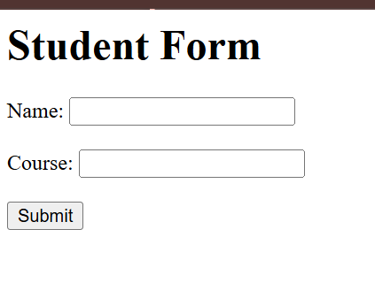
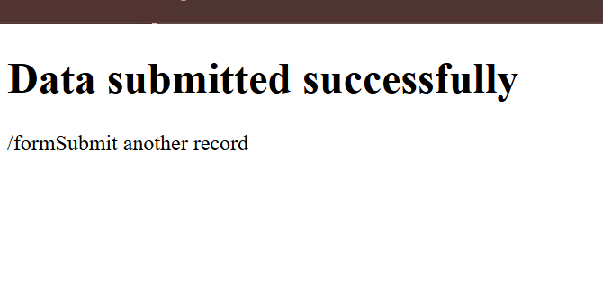

Final Result
Task 2 was completed successfully.
The Flask application now:
- Provides a frontend Student Form.
- Accepts Name and Course details.
- Stores submitted data in MongoDB Atlas.
- Redirects to a success page after successful insertion.
- Displays errors on the same form page without redirecting.

